PRACTICAL LIST – AY: 2026- 27
Sr. no. | Title | CO/PO
3. | Title : Cross Browser Testing using Selenium  Aim : To verify application compatibility across browsers.  Software Required  - Selenium  - Chrome  - Firefox  - Edge  Procedure  - Configure browser drivers.  - Execute same script.  - Compare results.  - Identify browser issues.  Expected Outcome: Cross-browser compatibility verified.  Result: Application tested on multiple browsers. | CO4 / PO1, PO2, PO3, PO5 and PO12
Solution:
1) Check python in system , “python --version” , “python3 --version”
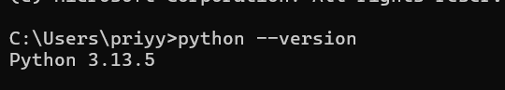
2) run command “pip3 install selenium”
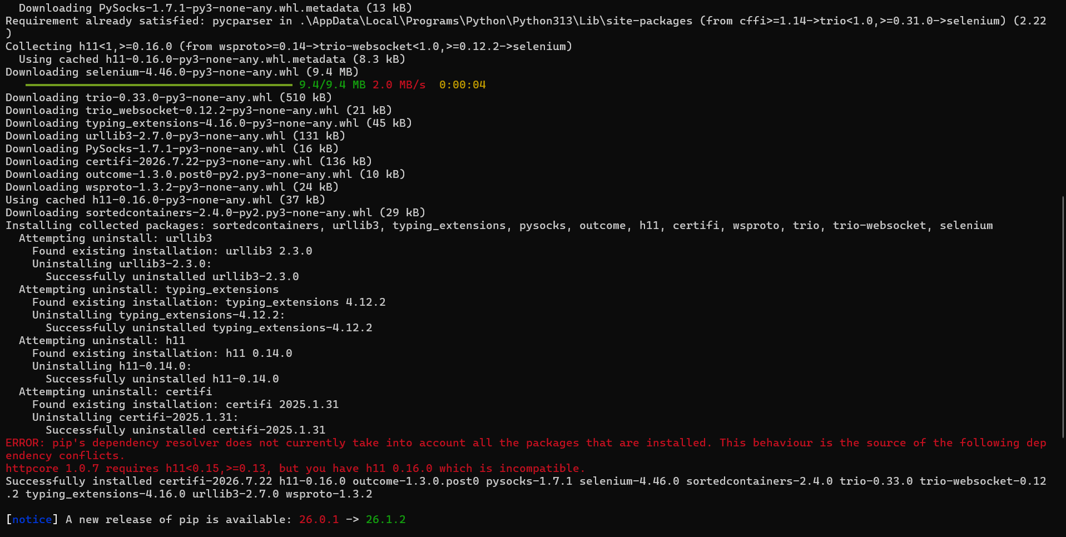

3)Open IDE and make “prac3.py” and write Script.
from selenium import webdriver
from selenium.webdriver.common.by import By
from selenium.webdriver.chrome.service import Service as ChromeService
from selenium.webdriver.firefox.service import Service as FirefoxService
from selenium.webdriver.edge.service import Service as EdgeService
from webdriver_manager.chrome import ChromeDriverManager
from webdriver_manager.firefox import GeckoDriverManager
from webdriver_manager.microsoft import EdgeChromiumDriverManager
import time
def run_test(browser_name):
print(f"\n--- Running test on {browser_name} ---")
# Launch Browser
if browser_name == "Chrome":
driver = webdriver.Chrome(
service=ChromeService(ChromeDriverManager().install())
)
elif browser_name == "Firefox":
driver = webdriver.Firefox(
service=FirefoxService(GeckoDriverManager().install())
)
elif browser_name == "Edge":
driver = webdriver.Edge(
service=EdgeService(EdgeChromiumDriverManager().install())
)
else:
print("Invalid Browser")
return
driver.implicitly_wait(10)
driver.maximize_window()
start_time = time.time()
# Open Website
driver.get("https://www.saucedemo.com")
# Login
driver.find_element(By.ID, "user-name").send_keys("standard_user")
driver.find_element(By.ID, "password").send_keys("secret_sauce")
driver.find_element(By.ID, "login-button").click()
time.sleep(2)
# Verify Title
print(f"{browser_name} - Page Title: {driver.title}")
try:
logo = driver.find_element(By.CLASS_NAME, "app_logo")
assert logo.is_displayed()
print(f"{browser_name} - Test Passed - Assertion Successful")
except Exception as e:
print(f"{browser_name} - Test Failed")
print(e)
end_time = time.time()
print(f"{browser_name} - Time Taken: {round(end_time - start_time, 2)} seconds")
print(f"{browser_name} - Waiting 4 seconds...")
time.sleep(4)
driver.quit()
# Run Test on All Browsers
run_test("Chrome")
run_test("Firefox")
run_test("Edge")
print("\nAll browser tests completed!")

Output :
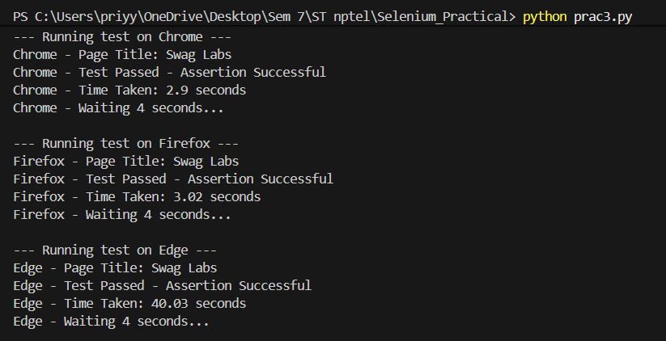
Reference Youtube Video:
https://www.youtube.com/watch?v=YEhnSrdLcHE

